Exp.No: 04 Vishalini.R

Date: 25-09-25 231701062

**Polygon Clipping**

**Aim:**

To write a program that clips a polygon to a specified rectangular clipping window using the **Sutherland–Hodgman Polygon Clipping Algorithm** and display the clipped polygon.

**Procedure:**

1. Start the program.
2. Input the coordinates of the polygon and the clipping window.
3. For each edge of the clipping window:
   * Take all vertices of the polygon as input list.
   * For every adjacent pair of vertices:
     + If the end vertex is inside the clipping edge:
       - If the start vertex is also inside, add end vertex to output list.
       - If the start vertex is outside, find intersection point with clipping edge and add intersection + end vertex to output list.
     + If the end vertex is outside but start is inside, find intersection point and add intersection point only.
   * Replace input list with output list for next edge.
4. After processing all edges, the output list contains the final clipped polygon vertices.
5. Display:
   * Draw original polygon.
   * Draw clipping window.
   * Draw clipped polygon in a different color.
6. Stop.

**Code:**

import matplotlib.pyplot as plt

def clip_polygon(subject_polygon, clip_window):

def inside(p, edge):

x, y = p

x1, y1, x2, y2 = edge

return (x2 - x1) * (y - y1) - (y2 - y1) * (x - x1) >= 0

def compute_intersection(p1, p2, edge):

x1, y1, x2, y2 = edge

px1, py1 = p1

px2, py2 = p2

A1 = py2 - py1

B1 = px1 - px2

C1 = A1 * px1 + B1 * py1

A2 = y2 - y1

B2 = x1 - x2

C2 = A2 * x1 + B2 * y1

det = A1 * B2 - A2 * B1

if det == 0:

return None

x = (B2 * C1 - B1 * C2) / det

y = (A1 * C2 - A2 * C1) / det

return x, y

output_list = subject_polygon

for i in range(len(clip_window)):

input_list = output_list

output_list = []

A = clip_window[i]

B = clip_window[(i + 1) % len(clip_window)]

for j in range(len(input_list)):

P = input_list[j]

Q = input_list[(j + 1) % len(input_list)]

if inside(Q, (A[0], A[1], B[0], B[1])):

if not inside(P, (A[0], A[1], B[0], B[1])):

intersection = compute_intersection(P, Q, (A[0], A[1], B[0], B[1]))

if intersection:

output_list.append(intersection)

output_list.append(Q)

elif inside(P, (A[0], A[1], B[0], B[1])):

intersection = compute_intersection(P, Q, (A[0], A[1], B[0], B[1]))

if intersection:

output_list.append(intersection)

return output_list

# Example Input

subject_polygon = [(50, 150), (200, 50), (350, 150), (350, 300), (250, 300)]

clip_window = [(100, 100), (300, 100), (300, 250), (100, 250)]

# Clipping

clipped_polygon = clip_polygon(subject_polygon, clip_window)

# Display

plt.figure()

subject_x, subject_y = zip(*subject_polygon)

plt.fill(subject_x, subject_y, 'skyblue', alpha=0.3, label='Original Polygon')

clip_x, clip_y = zip(*clip_window)

plt.plot(list(clip_x) + [clip_x[0]], list(clip_y) + [clip_y[0]], 'k--', label='Clipping Window')

if clipped_polygon:

clipped_x, clipped_y = zip(*clipped_polygon)

plt.fill(clipped_x, clipped_y, 'orange', alpha=0.6, label='Clipped Polygon')

plt.gca().set_aspect('equal')

plt.legend()

plt.title("Polygon Clipping - Sutherland–Hodgman")

plt.show()

**Output:**

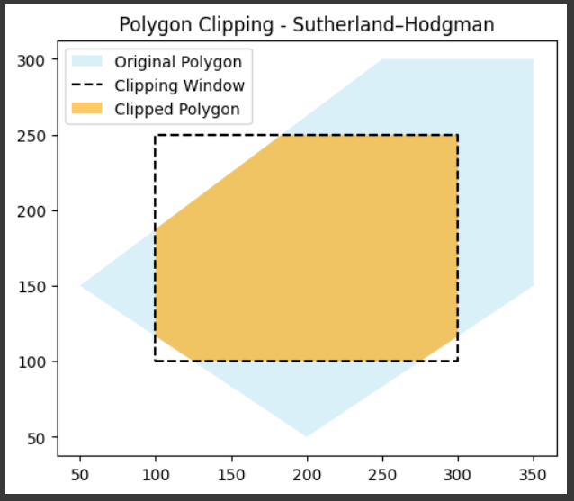

**Result:**

The program successfully clips the given polygon to the specified rectangular window.  
 The clipped polygon is displayed graphically along with the original polygon and clipping window.